AI Budget Enforcement & Usage Dashboard: Findings and Proposal
Nov 5, 2026 · @Chantal

Summary
The usage dashboard takes minutes to load because it most likely recomputes a month of AI usage from six ACCOUNT_USAGE views on every page load. The hourly enforcement task already does that exact work. The proposal: have the enforcement task save its results to three small tables once an hour, and have the dashboard read only those tables. Expected load time drops from minutes to about a second, and users see exactly the numbers that triggered any revoke.
The review also found three bugs in the current procedures. The most serious one can lock a user out for an extra month when they are revoked late on the last day of a month. All three are fixed in the proposed code.
The proposal is three files: hourly_revoke_v2.sql, reset_ai_v2.sql and ai_usage_dashboard.py. None of it has been run against Snowflake yet. It needs a dev test before rollout.

How the current system works
Snowflake only offers daily CoCo limits, so monthly AI budgets are enforced by our own procedures. There are four moving parts.
Part | What it does | When
ENFORCE_CORTEX_AI_LIMITS | Sums each user's month-to-date AI credits from six usage views. Revokes the tier role (AI_EXPLORER or AI_DATA_SCIENCE) from anyone over their budget in AI_ROLE_BUDGETS. Logs it to AI_ENFORCEMENT_LOG. | Hourly task
RESET_ALL_AI_ACCESS | Grants a tier role to every eligible DnA user who doesn't have one, plus manual assignments. Logs RESET rows. | 1st of each month
CoCo daily limits | Snowflake parameters capping each user at 10 credits per rolling 24 hours, separately for Snowsight, CLI and Desktop. Managers can approve 30-day exceptions. | Real time, enforced by Snowflake
Usage dashboard | Lets users see their own usage against their budget. Not yet deployed for general use. | On demand
The six usage sources are AI Functions, Cortex Analyst, Cortex Agents, Snowflake Intelligence, CoCo CLI and the Cortex REST API. REST API credits are estimated from token counts using a hard-coded rate table, because that view has no credits column.
The dashboard's job is narrow. Users should be able to tell whether they are close to their limit, and whether the errors they see are because their access was revoked.

Why the dashboard is slow
The dashboard's code isn't in the repo, so this is inferred from what it has to show. To report "all types" of AI usage against the budget, it has to run the same query the enforcement procedure runs. That query is expensive for four reasons:
- It reads six ACCOUNT_USAGE views. These are large, shared system views. They aren't tuned for fast interactive lookups.
- It scans the whole month every time. The filter is "since the 1st", so by month-end each load reads about 30 days of request-level rows from every source.
- It joins USERS three times and estimates REST API cost per request. That's extra work on every row.
- Streamlit reruns the whole script on every interaction. Without caching, each click repeats the full query.
Meanwhile, the source data only changes about once an hour: Snowflake documents up to an hour of latency on these views. Recomputing on every load gives users no fresher data than a result saved hourly.
The key point for the presentation: the expensive work is already done once an hour by the enforcement task. The dashboard is a second copy of the same work, run on demand.

Proposed design
The enforcement task already works out every user's month-to-date usage each hour. The proposal saves that result so the dashboard can read it instead of recomputing it.
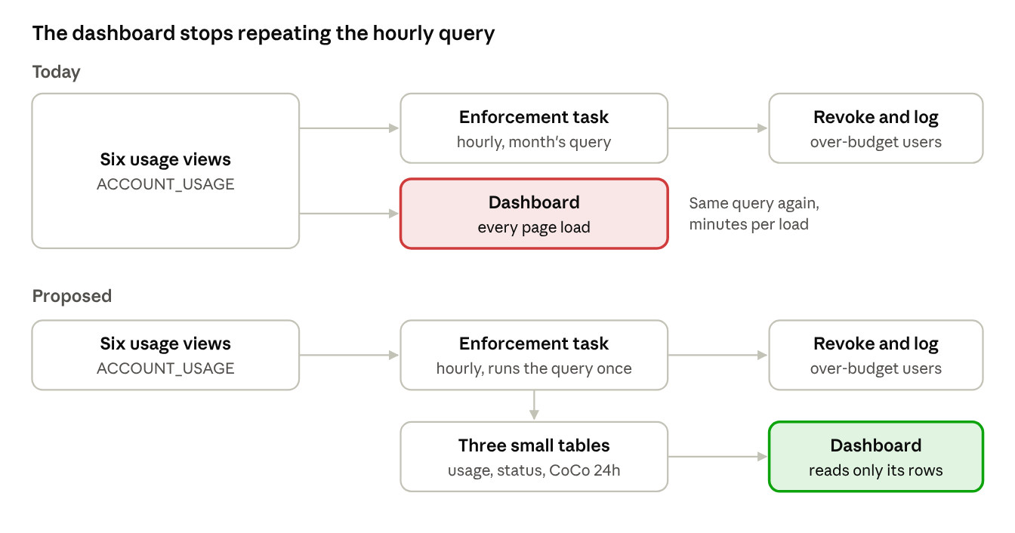
today vs proposed · where the month's usage query runs
Today the dashboard runs the same month-long query as the hourly task, once per page load. In the proposal, the task saves its results to three small tables, and the dashboard reads only the viewer's rows.
The new hourly run, in order:
- Rebuild this month's usage per user, day and source into AI_USAGE_DAILY. Same six sources and REST API rate table as today.
- Rebuild the status snapshot AI_USER_BUDGET_STATUS: every tier-role holder, plus anyone revoked this month (taken from the enforcement log). Each is marked ACTIVE, OVER_LIMIT or REVOKED.
- Revoke OVER_LIMIT users, log each one, and update their status.
- Refresh CoCo's last 24 hours in AI_COCO_24H_USAGE: usage per interface against each user's daily limit, including approved exceptions. This step runs on its own, so a failure here can't affect enforcement.
Because enforcement and the dashboard read the same tables, the numbers a user sees can't disagree with the numbers that triggered a revoke. The procedure keeps its name, so the existing hourly task needs no change.

Bugs found in the current procedures
Two of the three bugs come from one root cause: ACCOUNT_USAGE.GRANTS_TO_USERS can lag up to about two hours behind real grants and revokes. Both procedures use it to decide who currently holds a tier role.
Bug | What happens | Impact | Fix
Late-month revoke misses the reset | A user revoked shortly before midnight on the last day still looks like a role holder when the reset runs on the 1st. The reset skips them. | High. The user stays locked out for a whole extra month until someone notices. | reset_ai_v2.sql also re-grants everyone logged as REVOKED last month. Granting a role a user already holds is harmless.
Repeat revokes | A user revoked at 10:00 can still appear as a member at 11:00 and 12:00. They're revoked and logged again each run. | Medium. Duplicate log rows inflate revoke counts in reporting. If a repeat REVOKE ever errors, the next bug is triggered. | Users with a REVOKED log row this month (and no later RESET) are excluded from enforcement.
One failure stops the run | The revoke loop has no error handling. If one REVOKE fails, the procedure exits. | Medium. Every over-budget user after that one in the loop keeps access until the next run. | Each revoke runs in its own block. Failures are logged as REVOKE_FAILED and the loop continues.
A related design limit, not a bug: a user can go somewhat past 100% before the revoke lands. The check is hourly and the usage data can lag up to an hour, so up to about two hours of usage can pass before access is removed. The CoCo daily limits cap how much that can be. The dashboard explains this so a user who sees 104% isn't surprised.

What the new dashboard shows users
The dashboard answers the user's two questions in order: "am I close to my limit?" and "why am I getting errors?"
- Monthly AI budget. Credits used, the limit and what's left, with a progress bar. The status message depends on the user's state:
  - Active: a green confirmation, or a warning at 80% or more.
  - Over limit: access will be paused at the next hourly check.
  - Revoked: when the role was removed, the usage at that time, and the date access comes back.
  - No tier role: no budget applies, contact the admin team.
- CoCo daily limits, last 24 hours. Usage per interface against the daily limit of 10, or the user's approved exception and its end date. This is the part that separates the two kinds of errors: a daily-limit block affects one interface and clears on its own within 24 hours. A monthly revoke blocks everything until the 1st.
- Usage this month. A daily bar chart split by source, and a total per source, so users can see what used their credits.
The page also shows when the data was last refreshed, and notes that usage can lag up to about an hour.
Users no longer need any access to ACCOUNT_USAGE. The app reads three small tables, filtered to the person viewing it, and caches results for 10 minutes.

Open items to confirm before rollout
- ☐ Log timestamp column. The code assumes AI_ENFORCEMENT_LOG has a timestamp column named LOGGED_AT. Replace it with the real name in the places marked CHECK.
- ☐ Should CoCo in Snowsight and Desktop count toward the monthly budget? Today only the CLI counts. That may be intentional, but users will see Snowsight usage in the daily-limit section and expect it to count. Switching is a one-block change to SNOWFLAKE_COCO_USAGE_HISTORY, which covers all three interfaces. This is a policy decision for the team.
- ☐ Exception objects location. Replace admin_db.util with the schema where the CoCo exception procedures were deployed.
- ☐ Timezone alignment. Both procedures use the task session's timezone to decide when a month starts. The enforcement and reset tasks must run in the same timezone, or the month boundaries won't line up.
- ☐ Viewer identity in the app. The app identifies the viewer with st.user, falling back to CURRENT_USER(). Confirm with a non-owner account that it returns the viewer, not the app owner.
- ☐ Default daily limit. The procedure hard-codes 10. It should match the account-level CoCo parameters.

Rollout and testing plan
Roll out in dev first, and compare against the current procedure before switching production.
- Create the new tables and procedure in dev. Fill in the open items above first.
- Run the old and new enforcement side by side, without revoking. Comment out the REVOKE in a copy of the new procedure. Compare each user's month-to-date credits with the old query's result. They should match exactly, because the sources and rules are unchanged.
- Test the revoke path with a test user. Give a test user a tiny budget role, generate some usage, and confirm: one revoke, one log row, status REVOKED, and no repeat on the next run.
- Test the reset fix. Revoke the test user, then run the reset straight away (while GRANTS_TO_USERS still shows the old grant). The role should be re-granted.
- Test the dashboard as a normal user. Check load time, that each user sees only their own data, and each status message: active, 80%+, over limit, revoked, no tier role.
- Deploy to production. The procedure keeps its name, so the existing hourly task picks it up with no change. Deploy the reset fix before the next 1st of the month.

Questions to expect when presenting
Won't users see stale numbers if the data is only refreshed hourly? No staler than today. The source views themselves lag up to an hour, and enforcement only acts hourly. The dashboard now shows exactly what enforcement sees, with a "last updated" time.
Does this make the hourly task more expensive? Only slightly. The task already runs the six-view query. It now saves the results, which adds a small write. The new step for CoCo's last 24 hours is a small scan. The bigger saving is that the dashboard stops repeating the query for every visitor.
Does this change who gets revoked? No. Same sources, same REST API rate table, same rule (over the limit), same month boundary. The only behaviour changes are the bug fixes: no repeat revokes, and one failure no longer stops the run.
Why not just add caching to the existing dashboard? Caching helps the second visitor, not the first. The first load each cache period still takes minutes. Caching also doesn't fix the mismatch between what the dashboard computes and what enforcement computed.
What if the CoCo 24-hour step fails? It's isolated. Enforcement has already finished by then, and the failure is reported in the procedure's return message.
Why does a revoked user still appear on the dashboard? Once the role is removed, a grants-based lookup no longer finds their budget. The new status table takes revoked users from the enforcement log, so they see when and why access was paused, and when it returns.
Can a user see someone else's usage? No. The app filters every query to the viewing user. Users get no direct access to the tables or to ACCOUNT_USAGE.

Reference: new objects and files
All new tables live in AI_COST_MGMT.PUBLIC and are refreshed by ENFORCE_CORTEX_AI_LIMITS each hour.
Object | One row per | Used by
AI_USAGE_DAILY | user, day and usage source (this month) | Enforcement totals, dashboard charts
AI_USER_BUDGET_STATUS | user and tier role: limit, credits used, status, revoked time | Enforcement revoke list, dashboard status
AI_COCO_24H_USAGE | user and CoCo interface: last-24h credits, daily limit, exception end | Dashboard daily-limit section

File | Replaces | Change
hourly_revoke_v2.sql | hourly_revoke.sql | Saves results, skips already-revoked users, isolates failures, adds the CoCo 24-hour step. Same procedure name.
reset_ai_v2.sql | reset_ai.sql | Also re-grants users revoked last month.
ai_usage_dashboard.py | the current dashboard | Reads the three tables above, filtered to the viewer and cached.
Sources: SNOWFLAKE_COCO_USAGE_HISTORY view (latency up to 1 hour, all three CoCo interfaces) · CORTEX_CODE_DESKTOP_USAGE_HISTORY view

